**Excel Advanced Assessment**

1. Go to the IF sheet. Using the IF function on the range D4:D15, show “Alert” if the Percent in column C is more than 10, or blank text if it is not.

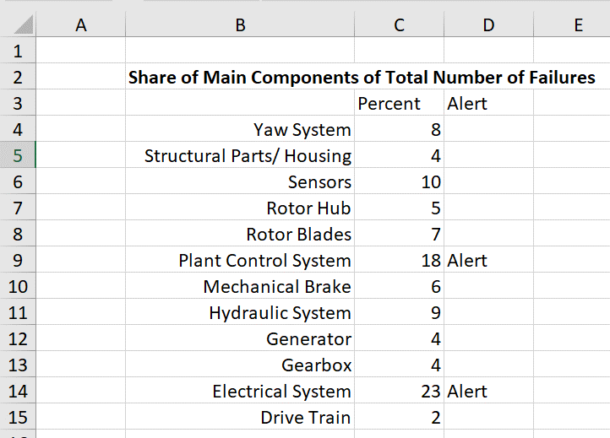

1. On the VLOOKUP sheet, use the VLOOKUP function in the range C4:C24 to find the Expected Times for each part. Then, subtract the Expected Times from the Production Times to get the Difference in D4:D24.

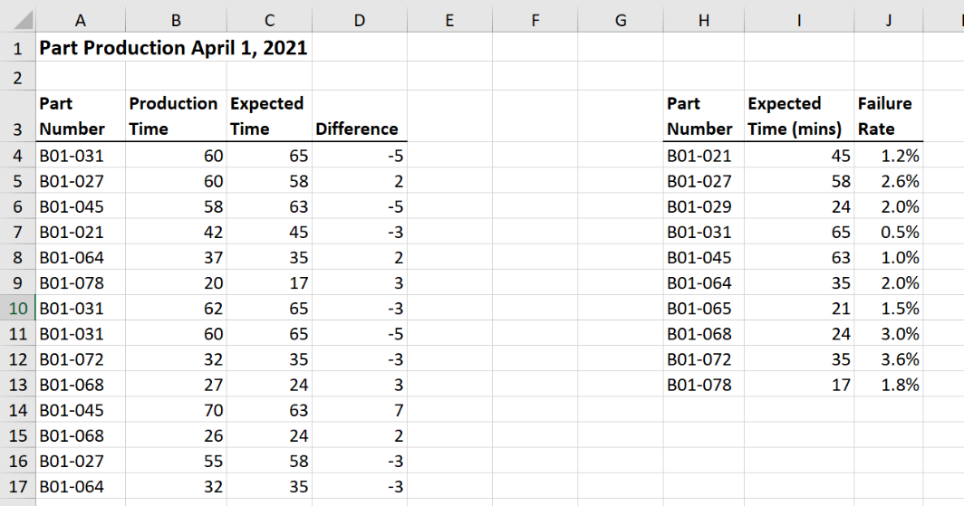

1. Go to the IPMT sheet. Using the IPMT function in cell C7, find the *interest* portion of the *first* payment under these circumstances:

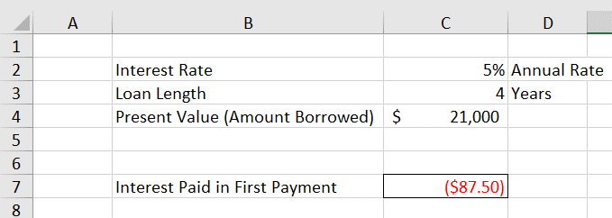

You should get $87.50

1. There is a Pivot Chart based on the data in the PivotData sheet. Go to the PivotChart sheet and add a Timeline to the chart so it only shows the Forklift training in 2015.

